**CSE211 Web Programming, Fall Semester 24/25**

**Assignment #1: Websites Conceptual Design and Mock-Up**

**Student ID: 222101930, Name: Yousef Ahmed Sabry**

**Evolution of the Web: From 2.0 to 4.0**

The World Wide Web, since its inception, has passed through a high tempo of transformation from static information storage to dynamic, interactive, and intelligent. This, of course, happened in clearly marked phases driven by technological changes backed up by rapid societal alterations.

**Web 2.0: The Social Web**

Further empowerment of the individual to participate actively in the digital realm was enabled through Web 2.0, which included user-generated content, social interaction, and collaboration. Key features of Web 2.0 are presented below:

Social Networking: The ability to establish and maintain connectivity through different social networking sites like Facebook and LinkedIn.

**Social Media:** Microblogging sites like Twitter and photo/video sharing sites like Instagram allow users to share information quickly and generate a community.

**Wikis**: collaborative work using online tools such as Wikipedia allowed collaborative creation and editing of content.

**Blogs:** personal blogging allows individuals to share with the rest of the world whatever they choose to share.

These features provided the functionality of networks in Web 2.0, connecting any one individual to any other, in a manner that is qualitatively allowing for completely new levels of collaboration and knowledge sharing.

**Web 3.0: The Semantic Web**

Web 3.0, also referred to as the Semantic Web, is about adding meaning to data and linking them together. Characteristics of Web 3.0 include:

Semantic Web Technologies: The RDF, OWL, and SPARQL technologies will thereby allow machines to understand and process information in a manner pretty much similar to that of humans.

Artificial Intelligence: AI-driven algorithms scan through vast amounts of data to determine patterns or insights hidden inside it.

Machine Learning: The algorithms of machine learning learn from data and hence keep improving with time.

Web 3.0 democratizes the meaning of data and knowledge connections by letting machines make out the context and understand the relations between different parts of information. This can bring a sea change in areas like healthcare, finance, and education.

**Web 4.0: The Intelligent Web**

Web 4.0, the future evolution of the Web, will be marked by an integration of Artificial Intelligence and the Internet of Things. The main features of Web 4.0 are described as mentioned below:

Intelligent Agents: AI-powered agents can interact with the users and perform tasks on behalf of the user.

**IoT:** Interlinking the Physical devices with the Internet to perform data collection and analysis in real-time.

Augmented Reality and Virtual Reality are immersive technologies to create newer dimensions for user experiences and interactions.

Web 4.0 will enable intelligence interconnections through the development of machine learning abilities for reasoning, decision-making, and autonomous processes. Digital experiences will become intelligent and more personalized.

Importance of Collective Intelligence, Social Networking, Social Media, and Social Bookmarking

Collective intelligence is the wisdom of the crowd, the group of people united by a single cause, and it is most definitely a force to be reckoned with. This collective intelligence can be harnessed through the use of social networking, social media, and social bookmarking to enable people to connect, collaborate, and share knowledge for problem-solving and innovation.

Empowering Current and Future Business Plans

Web 2.0, 3.0, and 4.0 are having a great amount of impact on businesses. Through these technologies, businesses can:

Improve Customer Experience: Provide personalized experiences, ensure better customer service, and build strong relationships with customers.

Optimize Operations: Automate processes, shrink resources and increase output.

Drive Innovation: Empower creativity, boost collaboration, and enable new offerings to be created.

Expand Market Reach: Address the global market and target specific audience groups.

Harness the Power of the Latest Technologies in My Line of Work

I will be able to apply the latest technologies in my line of work as a [Your Profession] in the following ways:

Improve Productivity: Repetitive tasks will be automated, thus making the workflow smooth.

**Better Decisioning:** Apply data analytics and AI to decision-making.

Stay Connected: Use social media and other digital tools to stay in touch with colleagues and clients anywhere.

Provide Innovative Solutions: Creative products or services that make full use of the Web's potential.

Since the Web is continuously changing, continuous learning and adaptation will enable me to remain relevantly competitive in the digital economy.

**Purpose of the Intended Website**

Our intended website is selling and showcasing women's wear, targeted at ages 18 to 40. It would be an online storefront for our family business where the customer can easily access the latest collections we may have or any promotions we may provide.

**Website Objectives**

We want the website to realize a few important objectives:

Increase Sales: We hope this will give us an opportunity to target a wider audience, rather than just the local market.

Brand Awareness Improvement: The website is supposed to be helpful in establishing our brand identity and values that will make sure our connection with customers is deep and friendly.

Customer Interaction: We want to have a place where we'll be able to interact with our customers, make them comment, review our products, share, and engage in our content.

Target Group

Our target group includes females between the ages of 18 and 40, who are after affordable yet trendy clothes. Target segments include students, young working ladies and mothers who care about style and quality.

Opportunities and Problems Addressed

The website that is set to be designed addresses a number of opportunities and problems:

Opportunity: The extension of our market to be able to accommodate online shoppers.

Problem: Poor visibility within a competitive market; this website will enhance visibility online.

Problem: Increased differentiation of customer tastes and preferences in fashion, about which the website can also advise by means of preselected collections and personalized recommendations.

**Website Content**

The website shall contain several types of content, including, but not limited to:

Product Lists: should provide high-quality images, item descriptions, and prices.

Blog Posts: will inform clients about fashion tips, style guides, and the latest news in fresh arrivals.

Customer Reviews: to establish trust and build the community.

Social Media Integration: Links to our social media for visitors' better exposure.

**Customer Service**

The client will be serviced through the website in terms of ease of use in browsing for and buying clothes. This entails features such as security in checkout, customer support chat, and ease of navigation that enhance service use.

**User Experience**

A clear-cut and intuitive layout will serve as the most efficient way users can achieve their goals, guiding them seamlessly through category browsing into product filtering and to checkout.

**Discovery of Function**

Web functionalities shall be accessed through engaging navigation menus, search functionality, among other call-to-action buttons like "Shop Now" or "Browse Collections."

**Result Reception**

The results of the user actions, such as subscribing to newsletters or buying something, will be received in the form of confirmation letters and personalized thank-you messages, further consolidating that fact they decided to shop with us.

**Receiver Actions**

These entries, whatever the form may be, be it an order, are timely processed to ensure timely shipment and customers' satisfaction

**Results Management**

It shall deal with the results analysis based on sales data, customer feedback, and website analytics to ensure continuous improvement of the user experience and products offered.

**Follow-up**

This will be followed up through newsletters regarding promotions, new arrivals, and engaging customers on social media. We will make sure to encourage feedback so that

Page 6 of 9

after the customer has made their purchases, a community can be developed.

**Related Websites**

ASOS (asos.com): I have chosen ASOS because the website offers a great selection of ladies' wear and that it is a very dynamic e-commerce website. Also, the way they engage users - through blogs and style guides - is what we strive to create.

Zara (zara.com): On the website, Zara presents its collections with a clean and minimalist aesthetic so that customers can view them easily. We use their effective seasonal promotion and how quickly they update for new styles as inspiration.

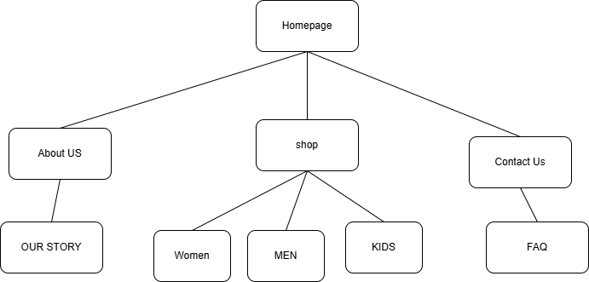

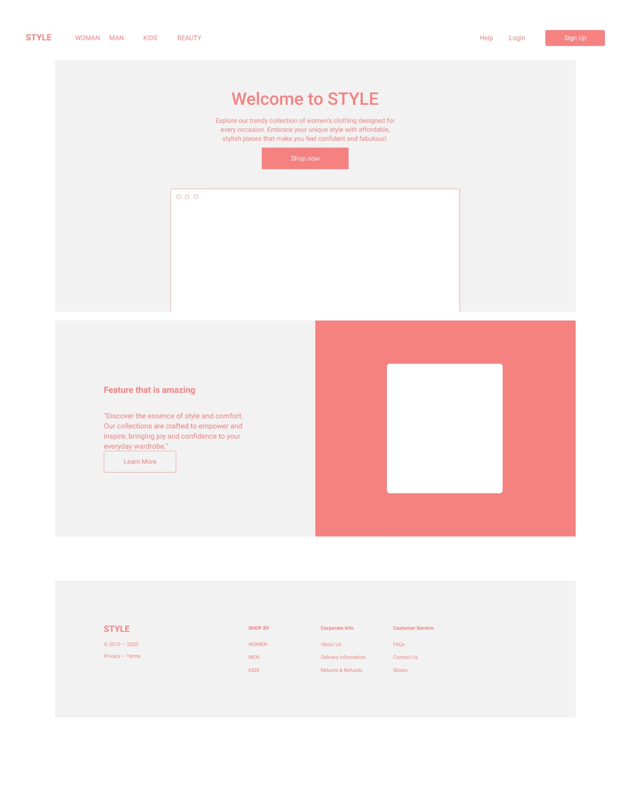

**REFERENCE**

FIGMA

DRAW.IO

ADOBE